Name: ____________________________________

Review 1.2-1.4

**Use the diagram to answer questions 1-3**

1. Name line x 4 different ways.
2. Name 5 different rays.
3. Name 2 different segments.

**Use the diagram to answer questions 4-7**

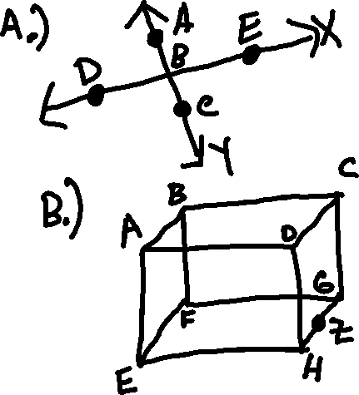

1. Name a line parallel to $\overset{⃡}{EF}$.
2. Name a plane parallel to Plane DCG.
3. Name the intersection of Planes EHD and ABC.
4. Name the intersection of $\overset{⃡}{BF}$ and $\overset{⃡}{FG}$.
5. Name 2 lines skew to $\overset{⃡}{CD}$.

**Decide whether the following are true or false using the above diagrams.**

1. _________ Plane EFGH can also be named Plane GZH. (Diagram B)
2. _________ Points A, B, and D are collinear. (Diagram B)
3. _________ Points E, H, and D are coplanar. (Diagram B)
4. $\vec{BD} and \vec{ED}$_________ are the same ray. (Diagram A)
5. $\overline{AB}$_________ and $\overset{̿}{BA}$ are the same segments. (Diagram A).
6. _________ Planes intersect at lines (Diagram B)

**Find the length of each segment.**

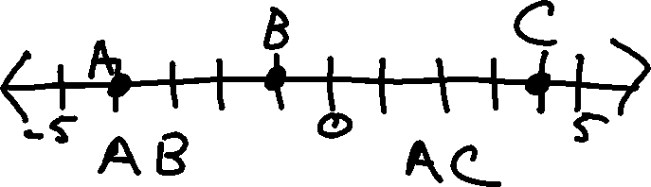

16.) 17.)

**Use the figure to answer the following questions:**



18.) If BC = 8 and CD = 38, then what is BD?

19.) If CD = 31 and BD = 44, then what is BC?

20.) GI = 36. Find x, GH, and HI.

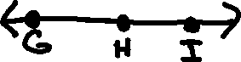

21.) Find y, TX, and TU.

